

VACCINATION MANAGEMENT SYSTEM

USER’S GUIDE:

Aptech North Karachi | CPISM | June 22, 2024

TABLE OF CONTENT:

* Home
* About Us
* Hospitals
* Vaccines
* Appointments
* Contact
* SIGN UP & SIGN IN

|  |  |  |
| --- | --- | --- |
|  |  |  |
| **ADVISOR/TEACHER/MENTOR** | SIR MUHAMMAD ADEEL | |
| **BATCH CODE** | 2307G1 | |
| **SERIAL NUMBER** | **ENROLLMENT NUMBER** | **STUDENT NAME** |
| 1 | Student1486692 | DANIAL MIRZA |
| 2 | Student1486713 | UZAIR AHMED KHAN |
| 3 | Student1487240 | ABDULLAH SHAKIL |
| 4 | Student1488154 | HAROON MUZAFFAR |



**HOME PAGE:**





ABOUT US

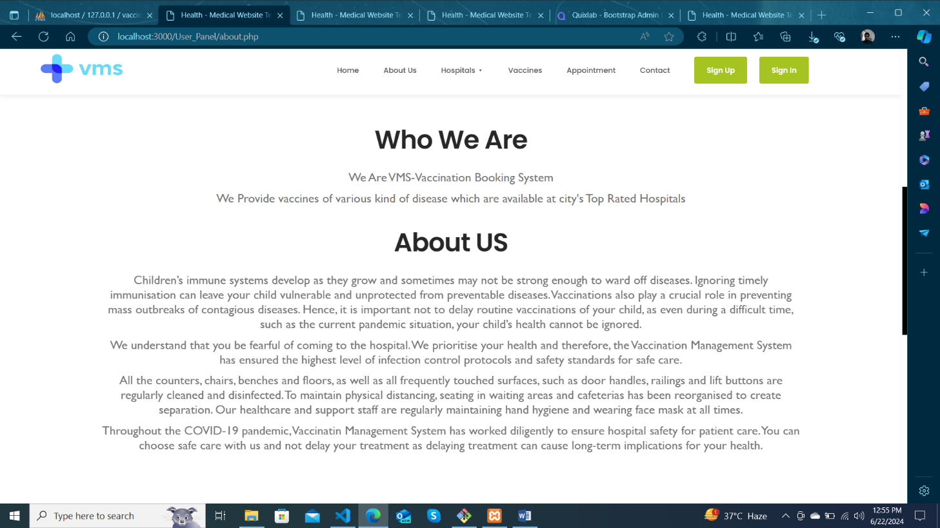

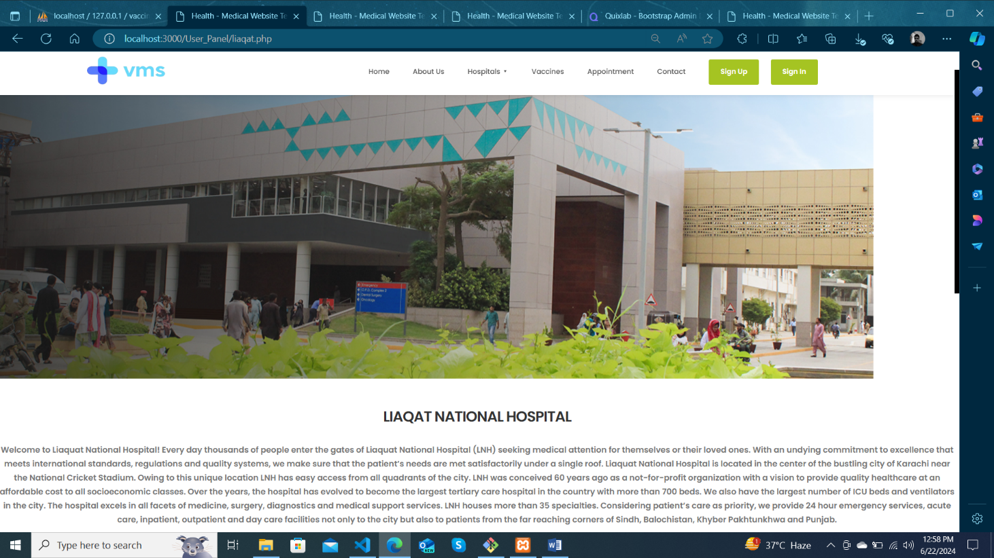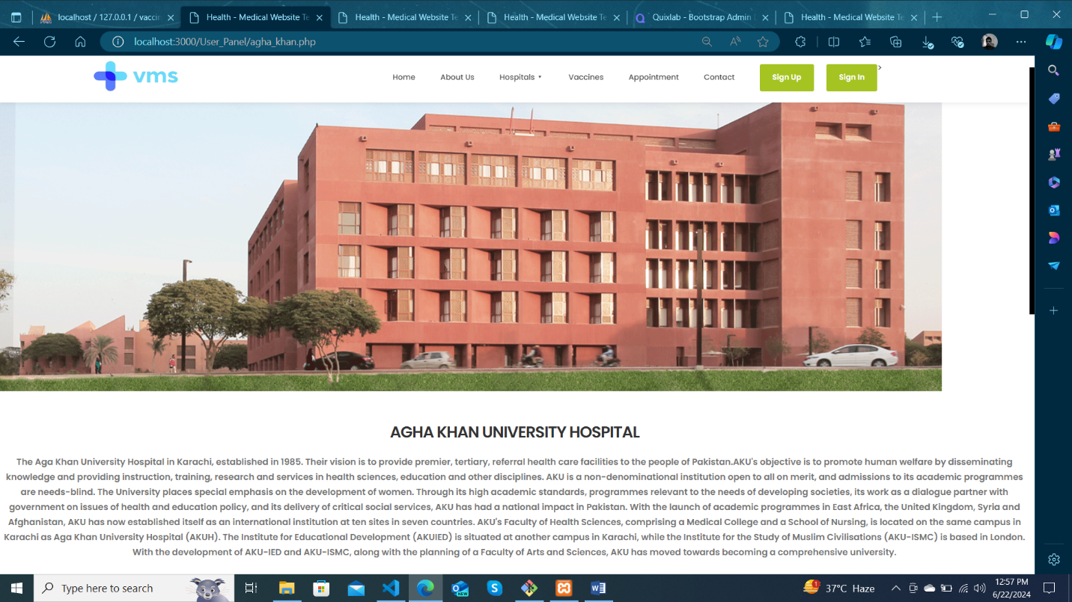HOSPITALS

HOSPITALS

(CONTINUE)



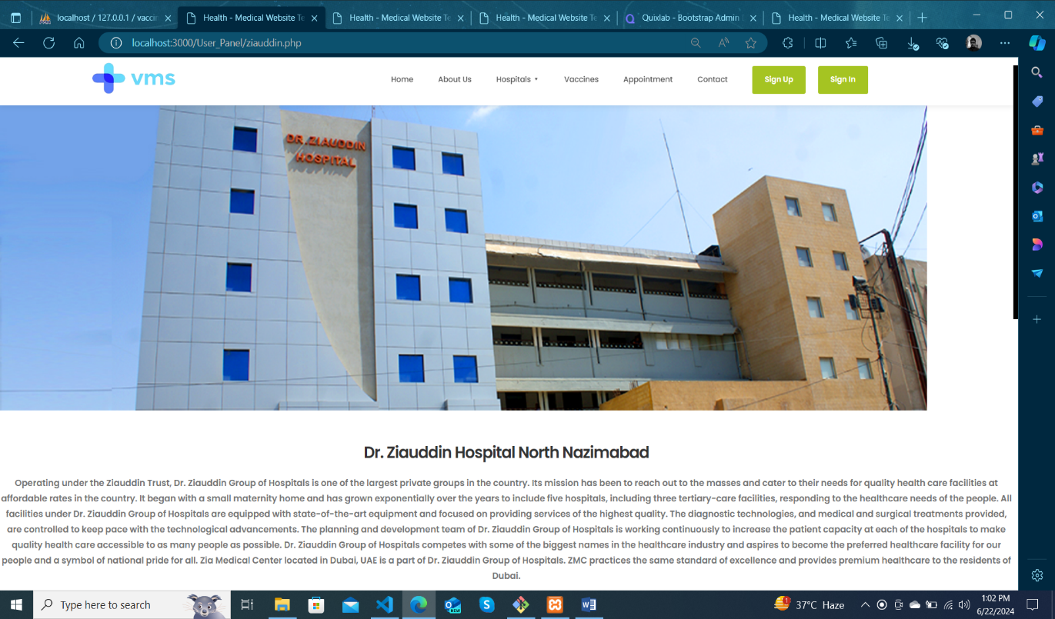

VACCINES

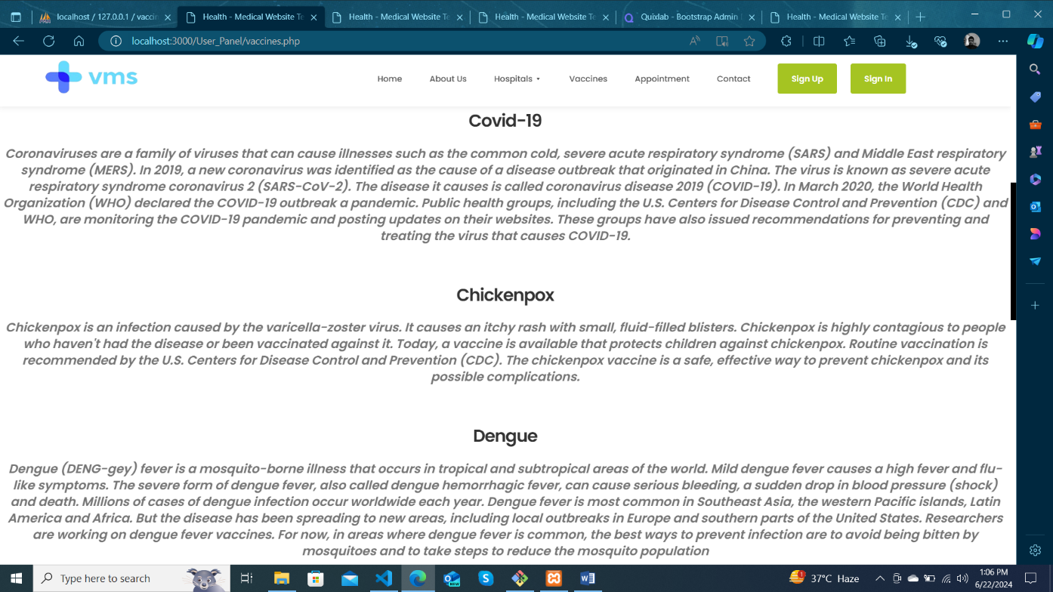

VACCINES

(CONTINUE)

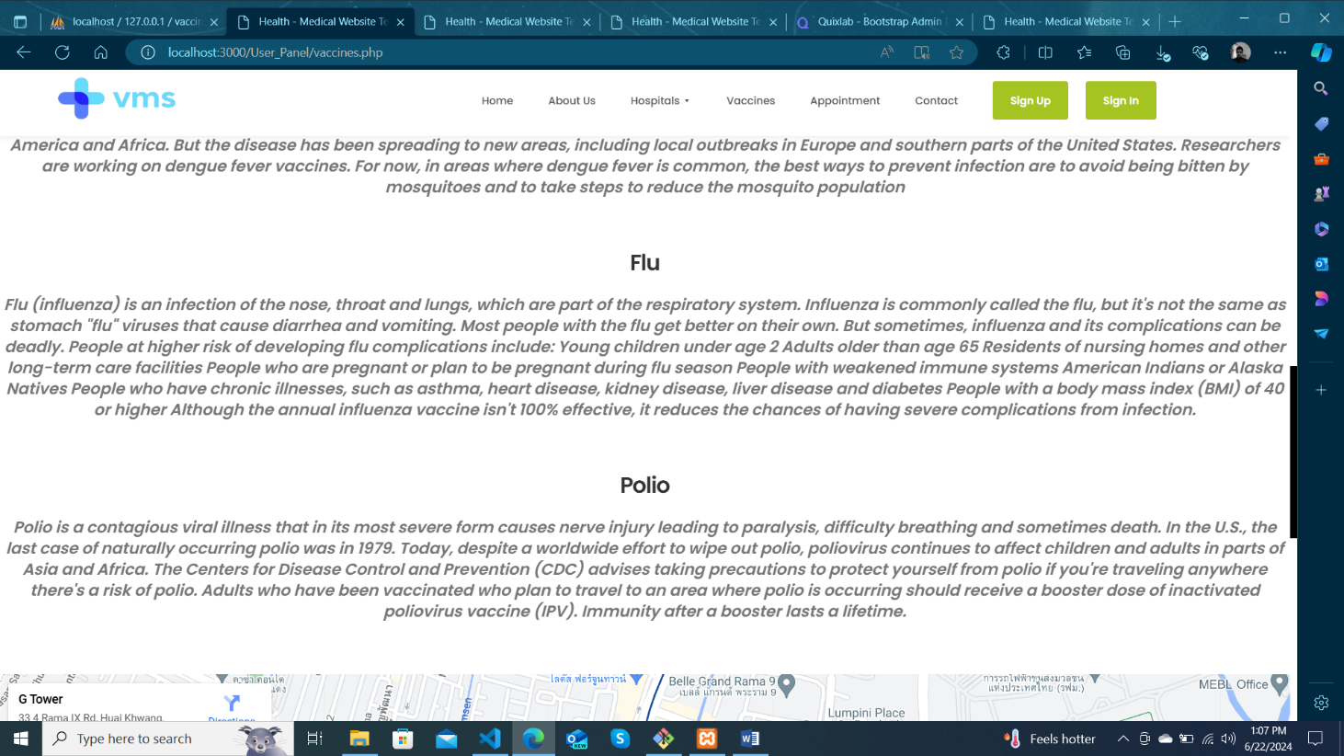

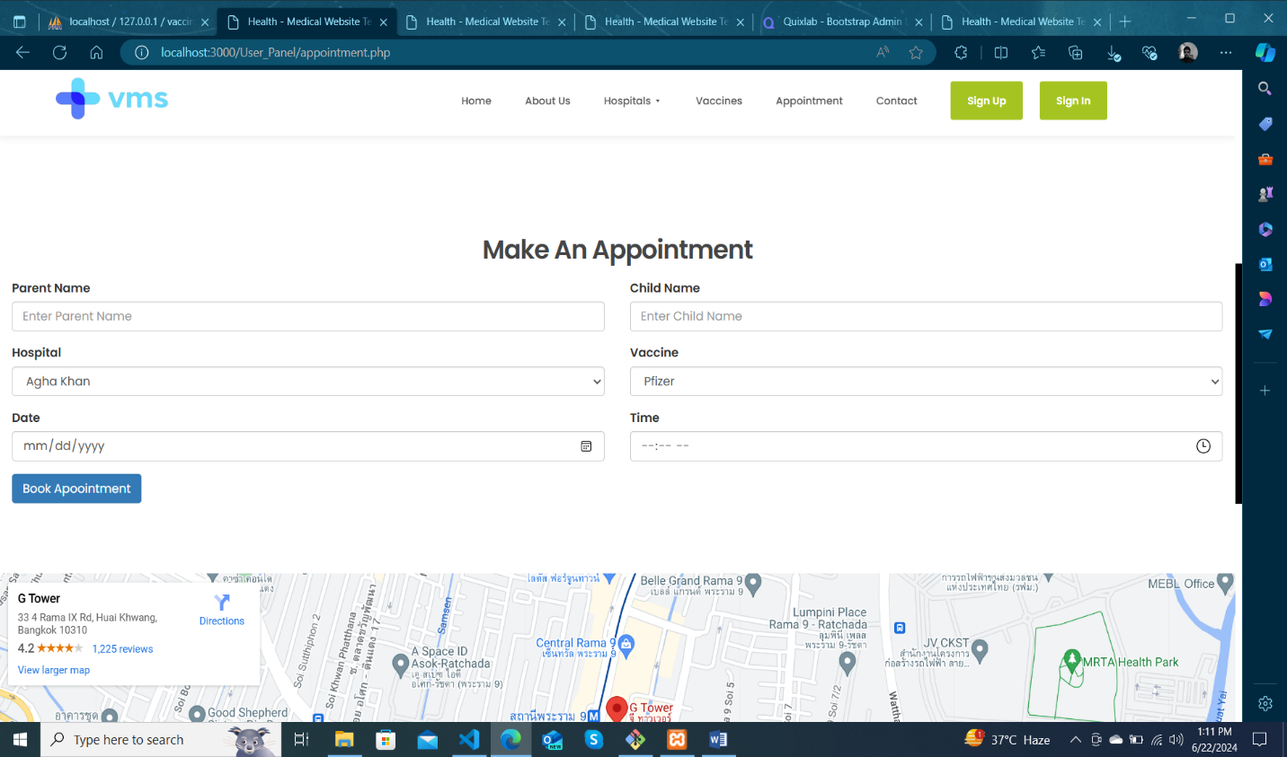APPOINTMENT

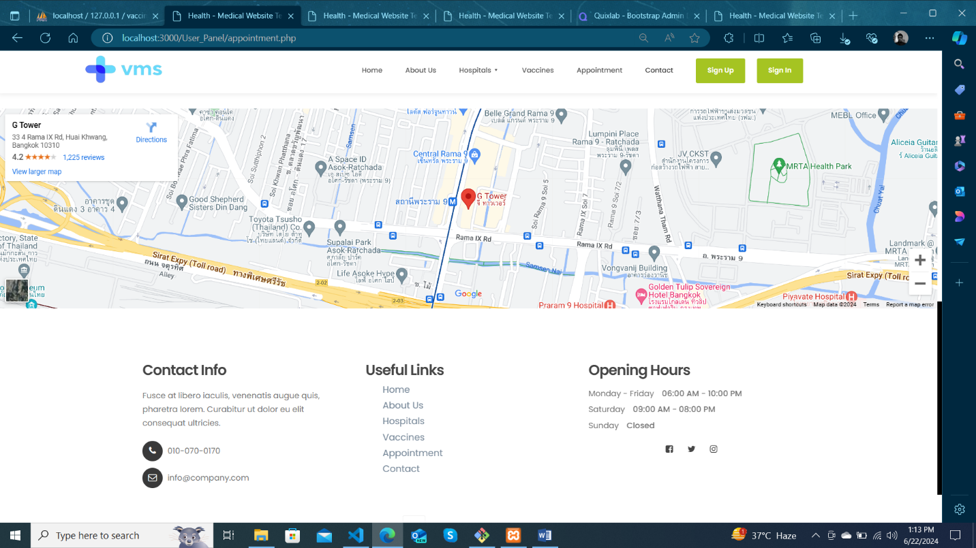CONTACT

SIGN UP & SIGN IN

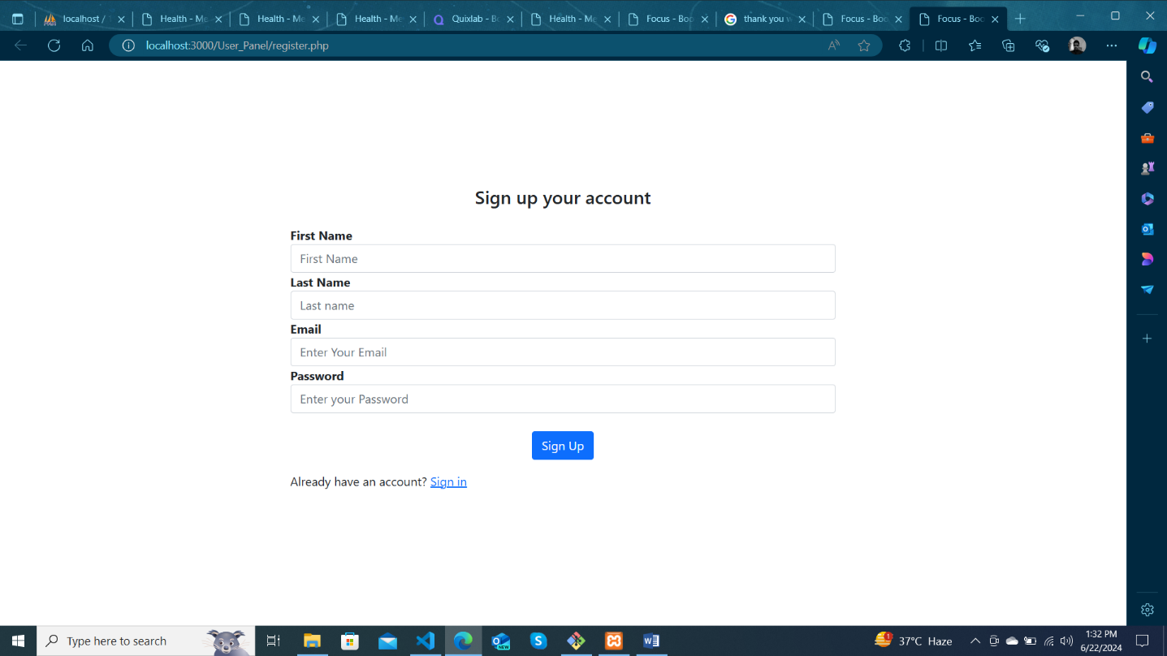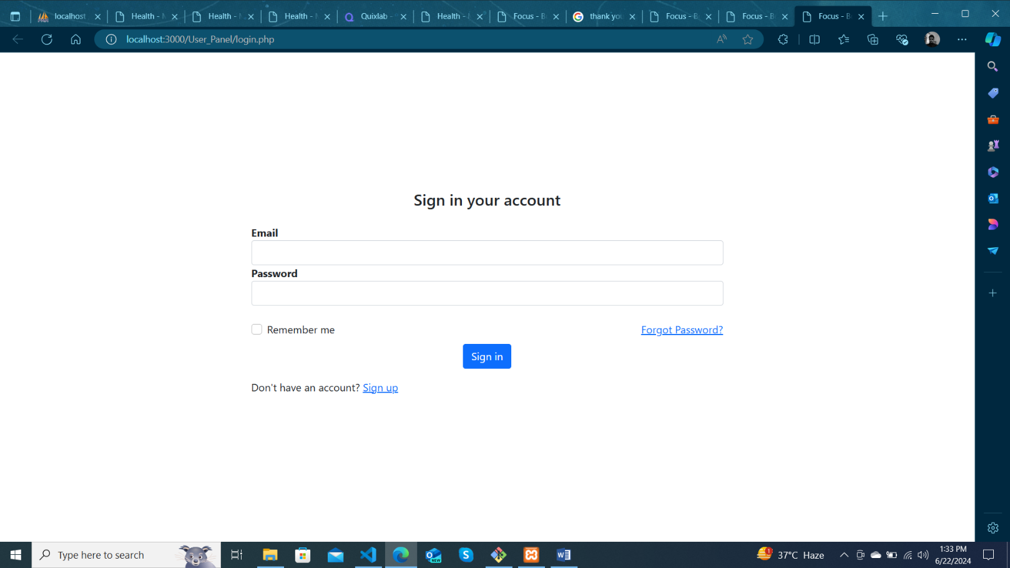

Thank you so much for reading our User Guide Manual of the Website.

